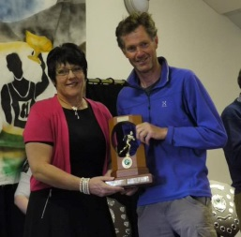
BRING IT ON!
by Alec Keith, 6 times winner of the 25 mile race
Alex tells me that this is going to be my 19th GWC, and as the fount of all GWC esoterica, he should know. That probably covers 18 completions - 2 rain-diverted Challenges, the one in Kintail, one 4-mile walk, and 14 “Big Ones”. The main reason for this slightly obsessive behaviour is purely selfish on my part – the view from the beginning of the steep descent to Carnmore is one of the top views in the country for me, as Fionn Loch and Dubh Loch suddenly open up below your feet, with the curtain of Beinn Lair forming the backdrop behind; and the GWC very kindly organises one’s transport logistics to simplify a one-day traverse of this amazing through route. But of course there’s more to it than that.
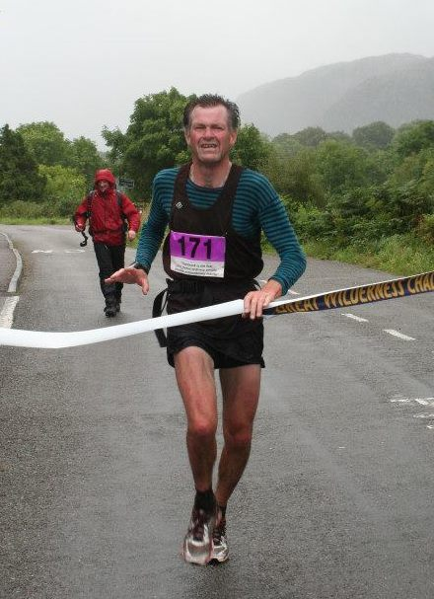
As a race route, this is one of the best. Over the years, the path has been improved, leading to a greater element of predictability, and perhaps some of the challenge has been lost in the process. The crux section used to be the gnarly mile or so of untracked bog before the Kernsary wood. The combination of tired legs and omnivorous tussocks very often had a dramatic effect on the race outcome; fresh-limbed young runners would enter it in the lead and emerge, decades older, onto the forest path, many places back, broken muddied and bloodied. A nice path detours round this section now, so such memories, along with commodities such as tripe and tapioca, are largely the fodder of folklore.
Many of the recent Challenges have taken place in comparatively benign conditions. But the toughest days for the runners are when the sun shines and the temperature rises. A few folk are built for running on humid late summer days in the Scottish hills; most are not, and if you’re one of the nots then you just have to listen to your body and pull the pace back to something that might just be sustainable for the next twenty-odd miles.
Apart from “the View”, my strongest memories of the GWC are those arising from a combination of pain and distress. My first event was on a baker of a day; not understanding the subtleties of the route, I shot off, established a lead before Shenavall, blew this by following the river banks to Larachantivore (rather than the more efficient direct bog-trog), buried myself in the heat to catch up with the pack again, and had overcooked completely long before Carnmore. The fact that my next actions were to swim at the causeway says it all. My racing efforts another year were undone by a catastrophic shoe malfunction after about 3 miles, the sole ripping off in a bog and being left attached to its upper at the toe by a thin strip of rubber; it was a long haul to Poolewe that year, made possible only by the generosity of fellow Challengers who freely surrendered their compass-strings and gaiter-laces to allow temporary repairs. And goodness knows the number of times David Hirst and I plunged into “the old Bog” before Kernsary, only to find our racing order redefined by cramp and general physical degradation.
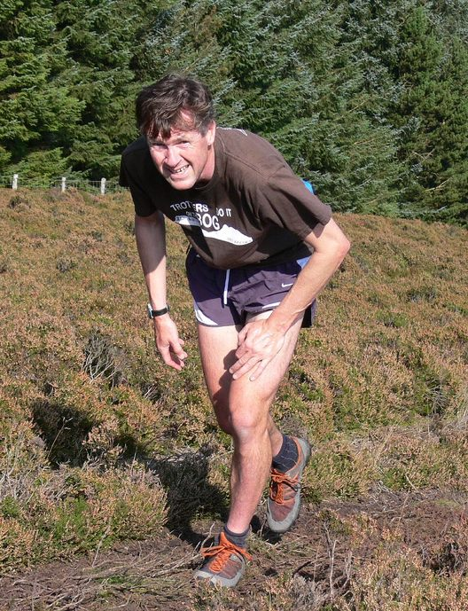
But away from the running is the Challenge as a whole, and there is another layer of memories– the camaraderie of other participants; cold showers in the old Portakabin blocks (long since superseded by the wonderful new village hall); the warmth of the welcome and hospitality of the local communities; the continuity and dedication of all who organise/marshal/cater/support and make the event run so smoothly; and the sense of being part of something that is genuine and worthwhile and special and gives to those who most need. Like everything and everyone, the GWC has needed to move with the times, to keep re-inventing itself, to embrace computerisation, and to bring aboard younger participants in the face of numerous other demands; but with characteristics such as these, the GWC’s future surely remains bright.
MEANTIME, BRING IT ON – AGAIN!

